JOB TITLE: Residential Specialist, weekend full-time

SUMMARY: Residential Specialists provide case management and support to Crittenton residents, helping them to feel empowered to achieve their goals.

REPORTS TO: Director of Residential Services

STATUS: Full-time, non-exempt

PAY RANGE: $24.04 per hour during 32-hour workweek trial*

SCHEDULE: Friday 7am – 7pm, Saturday 7am – 7pm, Sunday 7am – 3pm

Who we are:
Now in our 121st year of service to the Charlotte community, Crittenton is a non-profit organization whose mission is to empower women and children through education, health, residential care, and supportive services. We envision ending the generational cycle of poverty and trauma, creating better tomorrows. We’re nationally accredited and guided by a trauma-informed model of care to make our clients feel safe, supported, and empowered.
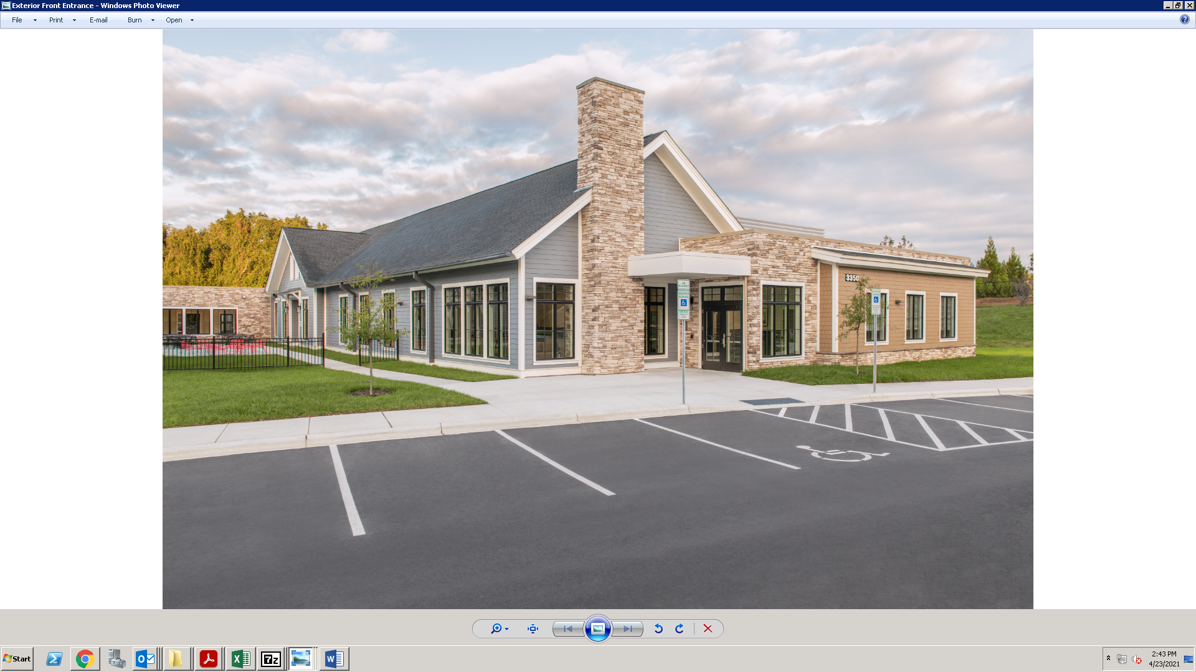
Want to see where you could be working?
Head to our website to view a virtual tour of our beautiful new 38,000 square-foot facility!
www.crittentonofnc.org
Working here:
*Crittenton is proud to be among the growing number of employers who are investing in their employees’ overall health, wellness, and job satisfaction by piloting a 32-hour workweek. Our pilot program will run from July 8, 2024 to October 5th, 2024. At that time, agency leadership will assess the program’s effectiveness and make a decision on its continuation. It is our sincere hope to make this a permanent benefit.

Residential Specialists work to maintain a compassionate and supportive environment for Crittenton residents during their stay. Work is performed with a goal of helping every individual feel valued, understood, and empowered to heal and thrive. We work in a unique and special environment, home to girls and women who may have substance use or mental health needs and many who are survivors of human sexual trafficking or who have experienced other forms of trauma. The ability to be sensitive to our resident’s circumstances and needs is critical. The ideal candidate will have experience working with at-risk youth, populations who have experienced trauma, and in residential group living environments, along with excellent customer service and communication skills.

Benefits:
Crittenton offers an innovative and competitive benefits package designed to enhance our employees’ work-life balance and support employee well-being. These benefits include:
- 32-hour workweek*
- Medical, Dental and Vision Insurance
- Company-paid Life & Accidental Death Insurance
- Company-paid Long Term Disability Insurance
- Flexible Spending & Dependent Care Account options
- Paid Time Off
- Paid Holidays
- Paid COVID sick leave
- Paid sabbatical leave
- 401(k)
- Employee Assistance Program
- Supplementary Voluntary Benefits
- Complementary meals during working hours
Specific Duties and Responsibilities:
- Participates in weekly Treatment Team clinical meetings to assist in development, implementation and revision of individual treatment plans; monitors progress toward treatment goals
- Works with the client on a day-to-day basis using professional judgment and discretion to implement the team-determined Treatment Plan
- Counsels and supports clients around issues of daily living to include, but not limited to chores, relationships, activity involvement, parenting and healthy pregnancy within area of expertise and limits of credentials; assures procurement of additional services as needed
- Consults and cooperates with community systems with the focus on attaining treatment goals
- Provides direct care for the clients’ children in client’s absence
- Organizes and supervises individual and group chore programs; conducts daily room and chore checks to ensure satisfactory completion
- Ensures clients follow program guidelines, rules and regulations at all times.
- Responds to clients’ medical symptoms and/or needs by following clinic instructions, administering medication, transporting and escorting into the hospital.
- Intervenes in problem behaviors by utilizing crisis intervention and redirection skills
- Documents all activities occurring and any new information disclosed on a client-by-client basis each shift, maintaining client and program records in accordance with applicable standards, grant requirements, etc.
- Provides supervision of clients in dining hall during meals
- Transports clients in agency vehicles to various appointments, court proceedings, etc.
- Participates in a minimum of 24 hours of continuing education activities annually
- Attend meetings as appropriate and meet regularly with supervisor to exchange pertinent information and receive supervision
- Works with supervisory assistance evaluating possible courses of conduct and making decisions where there is no opportunity to seek supervisory assistance
- Works together as a team with other Direct and Non-Direct Service staff
- Assists with serving meals as needed
- Maintains professional ethics as outlined in the NASW code of ethics

Qualifications:
- Must be able to work the required schedule of Friday 7am – 7pm, Saturday 7am – 7pm, Sunday 7am – 3pm
- Experience in residential care, at-risk youth or related human services area
- Strong interpersonal and organizational skills with a customer-focused attitude
- Ability to be sensitive to and understanding of the unique needs of the client population served
- Ability to read and comprehend information regarding adolescent development
- Excellent customer service skills
- Must be able to work as part of a team
- Must be CPR certified within 30 days of hire
- Must have clean driving record and valid driver license
- Commitment to Crittenton’s mission, vision, and values
- An understanding of basic computer programs, including Microsoft Word, Excel, and Outlook.
- Must pass background check and drug screening (answering “yes” to having a conviction(s) does not automatically disqualify you from employment. The nature of the offense, date of occurrence, and the job for which you are applying are also considered)

Crittenton is dedicated to diversity in our staff and our work. An Equal Opportunity Employer, we are committed to inclusivity in our hiring practices and we encourage members of all groups and communities to apply for this position. We do not discriminate on the basis of race, color, religion, national origin, gender, gender identity, sexual orientation, age, disability, veteran status, or genetic information. It is our intention that all qualified applicants are given equal opportunity and that selection decisions are based on job-related factors.

